**Chapter 4**

**Differentiation of Functions of Several Variables**

**4.1 Functions of Several Variables**

**Section Exercises**

**For the following exercises, evaluate each function at the indicated values.**

1. . Find , 

Answer:

1. . Find 

Answer: 

1. The volume of a right circular cylinder is calculated by a function of two variables, , where  is the radius of the right circular cylinder and  represents the height of the cylinder. Evaluate  and explain what this means.

Answer: . This is the volume when the radius is  and the height is .

1. An oxygen tank is constructed of a right cylinder of height  and radius  with two hemispheres of radius  mounted on the top and bottom of the cylinder. Express the volume of the cylinder as a function of two variables,  , find  and explain what this means.

Answer: , 

**For the following exercises, find the domain of the function.**

1. 

Answer: All points in the -plane

1. 

Answer: Outside or on the circle in the -plane with radius 

1. 

Answer: 

1. 

Answer: 

1. 

Answer: All real ordered pairs in the -plane of the form

1. 

Answer: All points in the -plane excluding those for which.

**Find the range of the functions.**

1. 

Answer: 

1. 

Answer: 

1. 

Answer: The set 

**For the following exercises, find the level curves of each function at the indicated value of to visualize the given function.**

1. , 

Answer: , a hyperbola

1. , 

Answer: , a hyperbola

1. 

Answer: , ; circles of radius, respectively

1. 

Answer: , a line; , line through the origin

1. 

Answer: , rotated hyperbolas

1. 

Answer:  ; three lines

1. 

Answer: ; parabolas opening upwards

1. 

Answer: 

1. 

Answer: 

1. 

Answer: 

1. 

Answer: 

1. 

Answer: 

1. 

Answer: 

1. 

Answer: 

1. 

Answer: 

1.   any constant

Answer: The level curves are parabolas of the form 

**For the following exercises, find the vertical traces of the functions at the indicated values of  and *y*, and plot the traces.**

1. 

Answer: A line 

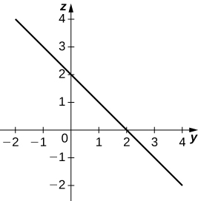

1. 

Answer: , a curve in the -plane with rulings parallel to the -axis

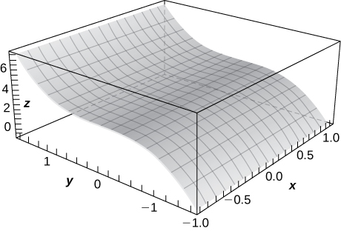

1. 

Answer:

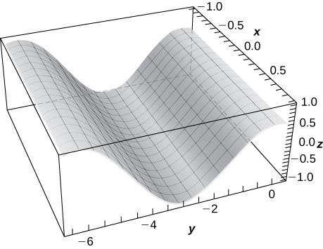

**Find the domain of the following functions.**

1. 

Answer: 

1. 

Answer: 

1. 

Answer: 

1. 

Answer: 

1. 

Answer: All points in -space

1. 

Answer: All points in the -plane

**For the following exercises, plot a graph of the function.**

1. 

Answer:

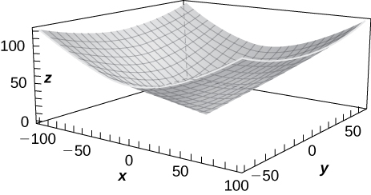

1. 

Answer:

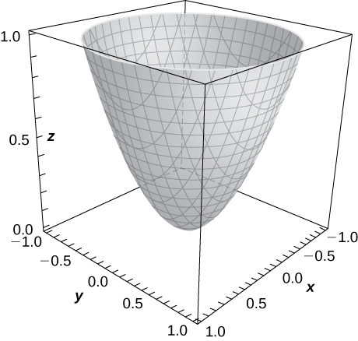

1. Use technology to graph .

Answer:

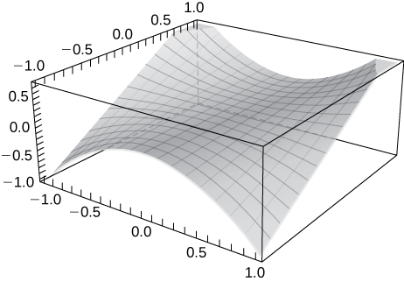

**Sketch the following by finding the level curves. Verify the graph using technology.**

1. 

Answer:

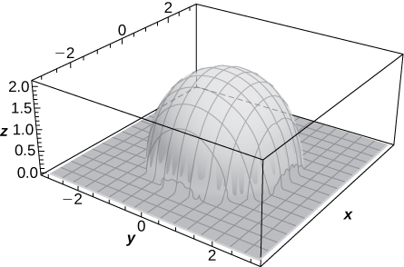

1. 

Answer:

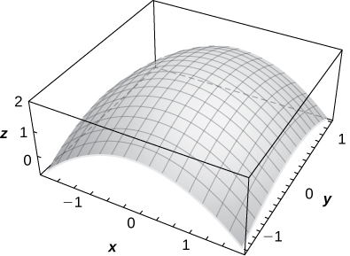

1. 

Answer:

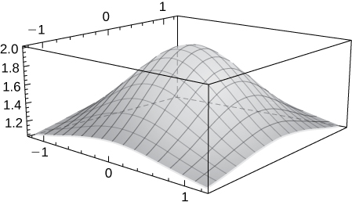

1. 

Answer:

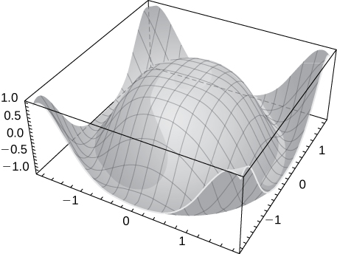

1. 

Answer:

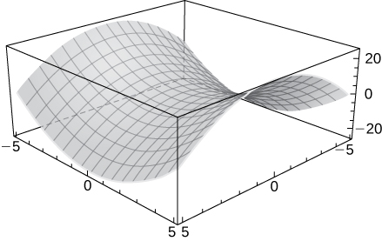

1. Describe the contour lines for several values of ** for .

Answer: The contour lines are circles.

**Find the level surface for the functions of three variables and describe it.**

1. 

Answer: , a plane

1. 

Answer:  a sphere of radius 

1. 

Answer: a hyperboloid of two sheets

1. 

Answer:  a hyperboloid of one sheet

1. 

Answer: 

**For the following exercises, find an equation of the level curve of  that contains the point *.***

1. 

Answer: 

1. 

Answer:

1. 

Answer: 

1. The strength  of an electric field at point  resulting from an infinitely long charged wire lying along the **-axis is given by  where ** is a positive constant. For simplicity, let and find the equations of the level surfaces for.

Answer:  

1. A thin plate made of iron is located in the -plane. The temperature in degrees Celsius at a point is inversely proportional to the square of its distance from the origin. Express  as a function of.

Answer: 

1. Refer to the preceding problem. Using the temperature function found there, determine the proportionality constant if the temperature at point. Use this constant to determine the temperature at point.

Answer: 

1. Refer to the preceding problem. Find the level curves for  and describe what the level curves represent.

Answer:   The level curves represent circles of radii  and 

This file is copyright 2016, Rice University. All Rights Reserved.